Testing as a Driver for Software Development

What is Testing as a Driver for Software Development
# Source: Chatgpt (GPT-5-Standard) at [8/13/2025]
Testing as a Driver for Software Development
means using testing not just as a check at the end, but as a guiding force throughout the software development process.
Instead of “build first, test later,” the testing process shapes design, coding, and delivery decisions from the start.

What It Means
# Source: Chatgpt (GPT-5-Standard) at [8/13/2025]
- Testing influences requirements – Tests clarify what “done” means.
- Testing shapes code structure – Writing tests first (e.g., TDD) impacts how developers design code.
- Testing accelerates feedback – Continuous testing helps detect issues immediately.
- Testing ensures maintainability – A solid test suite enables safe refactoring.

Key Approaches That Make Testing a Driver
# Source: Chatgpt (GPT-5-Standard) at [8/13/2025]
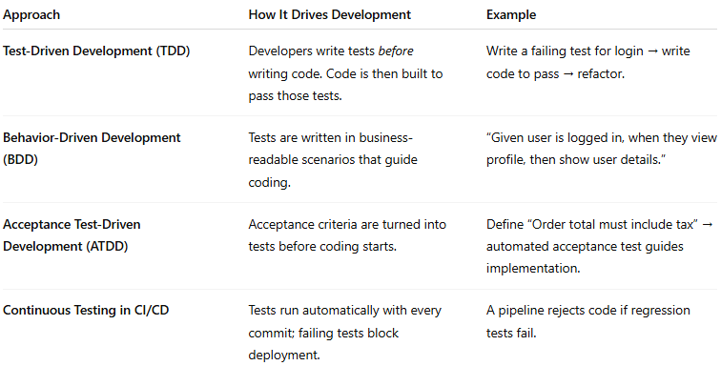
Approach | How It Drives Development | Example
Test-Driven Development (TDD) | Developers write tests before writing code. Code is then built to pass those tests. | Write a failing test for login → write code to pass → refactor.
Behavior-Driven Development (BDD) | Tests are written in business-readable scenarios that guide coding. | “Given user is logged in, when they view profile, then show user details.”
Acceptance Test-Driven Development (ATDD) | Acceptance criteria are turned into tests before coding starts. | Define “Order total must include tax” → automated acceptance test guides implementation.
Continuous Testing in CI/CD | Tests run automatically with every commit; failing tests block deployment. | A pipeline rejects code if regression tests fail.

Benefits of Testing-Driven Development
# Source: Chatgpt (GPT-5-Standard) at [8/13/2025]
- Early Defect Prevention – Bugs found in design phase are cheaper to fix.
- Clear Definition of Done – Tests specify expected behavior explicitly.
- Better Code Quality – Code is modular and testable.
- Faster Feedback – Developers get immediate alerts if changes break something.
- Supports Agile & DevOps – Fits into short, iterative cycles with automation.

How It Fits in the SDLC
# Source: Chatgpt (GPT-5-Standard) at [8/13/2025]
- Requirements Phase → Define testable acceptance criteria.
- Design Phase → Plan test scenarios alongside system design.
- Implementation → Write tests first (TDD/BDD), then implement code.
- Testing Phase → Automated regression suite verifies all requirements.
- Maintenance → Existing tests guard against new defects.

Types

1-Test-Driven Development (TDD)

What is Test-Driven Development (TDD)
# Source: Chatgpt (GPT-5-Standard) at [8/13/2025]
Test-Driven Development (TDD) is a software development approach where you write automated tests before writing the actual code.
It follows a short, repeatable cycle called Red → Green → Refactor:

The TDD Cycle
# Source: Chatgpt (GPT-5-Standard) at [8/13/2025]
- Red – Write a small, failing test (because the feature/code doesn’t exist yet).
- Green – Write just enough code to make the test pass.
- Refactor – Improve the code’s structure and readability while keeping tests passing.
Then repeat the cycle for the next small feature.

How It Works (Example)
# Source: Chatgpt (GPT-5-Standard) at [8/13/2025]
Let’s say we need a function to add two numbers:
- Step 1: Write a test: “add(2, 3) should return 5” → it fails (Red).
- Step 2: Write minimal code: return a + b; → test passes (Green).
- Step 3: Refactor if needed (e.g., handle edge cases) → tests still pass.

Scenario: We want a function add(a, b) that returns the sum of two numbers.

Step 1: Write a Test (RED phase)
# Source: Chatgpt (GPT-5-Standard) at [8/13/2025]
- Goal: Define the expected behavior before writing the actual function logic.
- Action: Write a test that says: “If we add 2 and 3, the result should be 5.”
- Why first? Forces you to think about the requirements and API before coding the solution.
- Result: Since the function doesn’t exist yet (or is unimplemented), the test fails.
- Status: RED — this indicates the code doesn’t yet meet the requirement.
Example (Python + pytest):
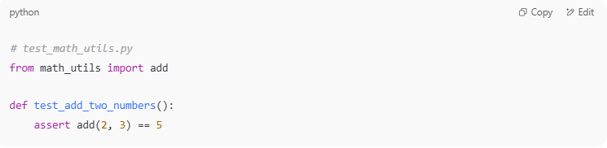
# test_math_utils.py
from math_utils import add

def test_add_two_numbers():
assert add(2, 3) == 5

If add is not defined, pytest will throw an error:
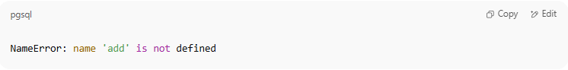
NameError: name 'add' is not defined

Step 2: Write Minimal Code (GREEN phase)
# Source: Chatgpt (GPT-5-Standard) at [8/13/2025]
- Goal: Write the simplest code to make the test pass — no extra features, no optimizations.
- Action: Implement add(a, b) so that it returns the sum.
- Why minimal? Prevents overengineering and keeps you focused on passing the current test.
- Result: The test passes.
- Status: GREEN — requirement met.
Example:
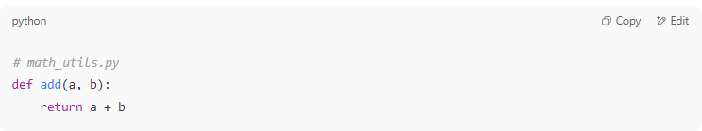
# math_utils.py
def add(a, b):
return a + b

Run the test again:
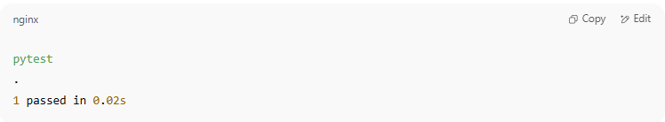
pytest
.
1 passed in 0.02s

Step 3: Refactor (REFACTOR phase)
# Source: Chatgpt (GPT-5-Standard) at [8/13/2025]
- Goal: Clean up code or improve design without changing its behavior.
- Action:
  - Improve naming
  - Remove duplication
  - Add handling for edge cases (optional, if needed now)
- Why now? The tests ensure you’re not breaking functionality while improving code.
- Result: Code is cleaner, tests still pass.
- Status: Still GREEN.
Example refactor — maybe you decide to handle None inputs:
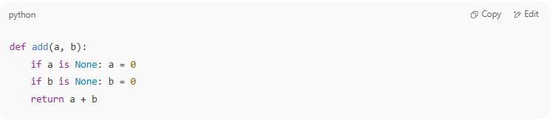
def add(a, b):
if a is None: a = 0
if b is None: b = 0
return a + b

Run tests again — still pass:
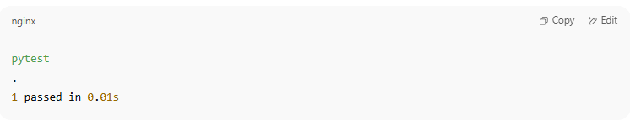
pytest
.
1 passed in 0.01s

Red → Green → Refactor Loop Summary
# Source: Chatgpt (GPT-5-Standard) at [8/13/2025]
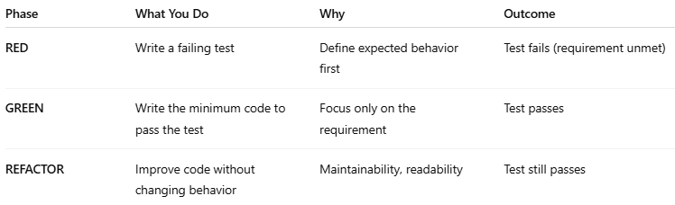
Phase | What You Do | Why | Outcome
RED | Write a failing test | Define expected behavior first | Test fails (requirement unmet)
GREEN | Write the minimum code to pass the test | Focus only on the requirement | Test passes
REFACTOR | Improve code without changing behavior | Maintainability, readability | Test still passes

💡 Key Point:
TDD makes automated tests the driver of your development. Over time, you build a safety net of tests that catches regressions when you change code later.

If you want, I can give you the same example in a flow diagram so you can visualize the TDD cycle for this case.

Benefits
# Source: Chatgpt (GPT-5-Standard) at [8/13/2025]
- Fewer bugs – Problems are caught early.
- Better design – Writing tests first forces modular, testable code.
- Confidence in changes – Safe refactoring thanks to passing tests.
- Living documentation – Test cases explain how the code is expected to behave.

Common Misunderstandings
# Source: Chatgpt (GPT-5-Standard) at [8/13/2025]
- Not only for testers – It’s primarily a developer practice.
- Not writing all tests upfront – You write one small test at a time.
- Not only for new projects – You can apply TDD to maintenance and bug fixes.

TDD vs. Traditional Development
# Source: Chatgpt (GPT-5-Standard) at [8/13/2025]
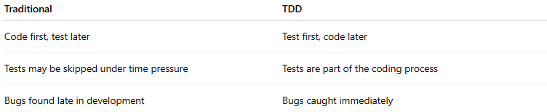
Traditional | TDD
Code first, test later | Test first, code later
Tests may be skipped under time pressure | Tests are part of the coding process
Bugs found late in development | Bugs caught immediately

2-Behavior-Driven Development (BDD)

What is Behavior-Driven Development (BDD)
# Source: Chatgpt (GPT-5-Standard) at [8/13/2025]
Behavior-Driven Development (BDD) is a software development approach that extends TDD by focusing on the behavior of the application from the user’s perspective.
It uses plain, human-readable language (often “Given–When–Then” format) so that developers, testers, and business stakeholders can collaborate on defining expected outcomes before coding starts.

Core Idea
# Source: Chatgpt (GPT-5-Standard) at [8/13/2025]
- TDD asks: "What code should we write to pass this test?"
- BDD asks: "What behavior should the system show for this scenario?"
- Tests are written in a shared language so everyone understands them.

The BDD Flow
# Source: Chatgpt (GPT-5-Standard) at [8/13/2025]
- Discuss – Developers, testers, and stakeholders define requirements as behaviors.
- Describe – Write scenarios in a structured format (Gherkin language).
- Implement – Automate these scenarios as tests and write code to make them pass.

Example (Gherkin format)
# Source: Chatgpt (GPT-5-Standard) at [8/13/2025]
Feature: Login Function
Scenario: Successful login with valid credentials
Given the user is on the login page
When the user enters valid username and password
Then the user should be redirected to the dashboard

- Given – Setup or context.
- When – Action or event.
- Then – Expected outcome.

Scenario: Successful login with valid credentials

1. Given – Setup / Context
# Source: Chatgpt (GPT-5-Standard) at [8/13/2025]
- Purpose: Describe the initial state or preconditions before the main action.
- Meaning in this case:
  - The user has already navigated to the login page of the application.
  - The application is up and running.
  - There’s an account with valid credentials in the system.
BDD Representation:
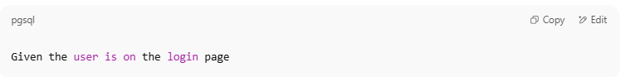
Given the user is on the login page

Technical Setup Example (Selenium + Python):
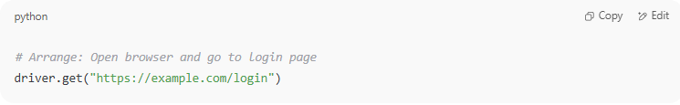
# Arrange: Open browser and go to login page
driver.get("https://example.com/login")

2. When – Action / Event
# Source: Chatgpt (GPT-5-Standard) at [8/13/2025]
- Purpose: Describe the specific action the user takes.
- Meaning in this case:
  - The user types a valid username and password into the login form.
  - The user clicks the "Login" button.
BDD Representation:
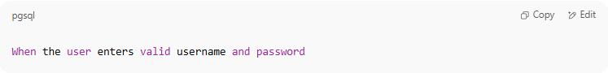
When the user enters valid username and password

Technical Implementation Example:
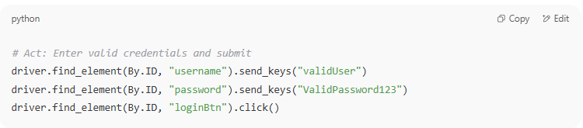
# Act: Enter valid credentials and submit
driver.find_element(By.ID, "username").send_keys("validUser")
driver.find_element(By.ID, "password").send_keys("ValidPassword123")
driver.find_element(By.ID, "loginBtn").click()

3. Then – Expected Outcome
# Source: Chatgpt (GPT-5-Standard) at [8/13/2025]
- Purpose: Define the result that should happen after the action, if everything works correctly.
- Meaning in this case:
  - The application should authenticate the credentials.
  - The user should be redirected to the dashboard page.
BDD Representation:
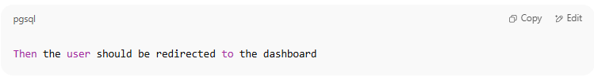
Then the user should be redirected to the dashboard

Technical Verification Example:
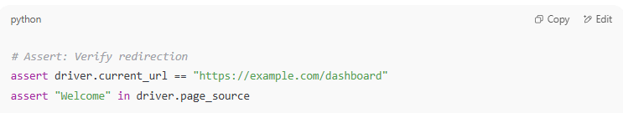
# Assert: Verify redirection
assert driver.current_url == "https://example.com/dashboard"
assert "Welcome" in driver.page_source

Full Example in Gherkin Syntax
# Source: Chatgpt (GPT-5-Standard) at [8/13/2025]
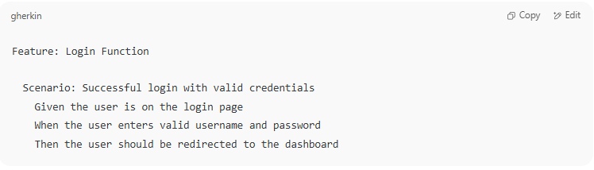
Feature: Login Function

Scenario: Successful login with valid credentials
Given the user is on the login page
When the user enters valid username and password
Then the user should be redirected to the dashboard

How It Fits into BDD
# Source: Chatgpt (GPT-5-Standard) at [8/13/2025]
- Feature = High-level description of what we’re testing (Login function).
- Scenario = One concrete example of behavior (valid login).
- Given = Sets up initial state (login page is open).
- When = Describes the trigger/action (entering credentials and submitting).
- Then = Describes the outcome (redirect to dashboard).

Visual Flow
# Source: Chatgpt (GPT-5-Standard) at [8/13/2025]
- Given – Where are we starting? → Login page is loaded
- When – What action happens? → Enter valid credentials + click login
- Then – What should happen? → User lands on dashboard

Benefits
# Source: Chatgpt (GPT-5-Standard) at [8/13/2025]
- Shared understanding – Bridges communication gap between technical and non-technical teams.
- Living documentation – Scenarios double as documentation.
- Early defect detection – Misunderstandings in requirements are spotted before coding.
- Better collaboration – Encourages joint ownership of quality.

Common Tools
# Source: Chatgpt (GPT-5-Standard) at [8/13/2025]
- Cucumber (Java, JavaScript, Ruby)
- SpecFlow (.NET)
- Behave (Python)
- JBehave (Java)

3-Acceptance Test-Driven Development (ATDD)

What is Acceptance Test-Driven Development (ATDD)
# Source: Chatgpt (GPT-5-Standard) at [8/13/2025]
Acceptance Test-Driven Development (ATDD) is a software development approach where developers, testers, and business stakeholders collaborate to define acceptance tests before any coding begins.
These acceptance tests represent the criteria for success — the system must meet them for the feature to be considered complete.

Acceptance tests

What is Acceptance tests
# Source: Chatgpt (GPT-5-Standard) at [8/13/2025]
Acceptance tests are tests that verify whether a software system meets the business requirements and acceptance criteria agreed upon by stakeholders.
They are the proof that a feature or product is complete and works as intended from the end user’s perspective.

Key Characteristics
# Source: Chatgpt (GPT-5-Standard) at [8/13/2025]
- Business-Focused – They test what the system should do, not how it’s built.
- Criteria-Based – They are directly derived from the acceptance criteria in the requirements.
- High-Level – They validate the overall behavior of the system, often spanning multiple components.
- Collaboratively Defined – Usually written by developers, testers, and business stakeholders together.
- Executable – In Agile and ATDD, they are often automated so they can run repeatedly.

Purpose
# Source: Chatgpt (GPT-5-Standard) at [8/13/2025]
- Confirm that the feature meets the Definition of Done.
- Ensure that the delivered functionality satisfies end-user needs.
- Reduce misunderstandings between business and technical teams.
- Serve as a contract for the feature’s behavior.

Example – E-commerce Order
# Source: Chatgpt (GPT-5-Standard) at [8/13/2025]
Acceptance Criteria:
If a product costs $100 and the tax rate is 10%,
the total order cost should be $110.
Acceptance Test (Gherkin style):
Feature: Order total calculation

Scenario: Order total includes tax
Given I have a product costing $100
And tax rate is 10%
When I place the order
Then the total should be $110

✅ If this test passes, the feature is considered accepted.

Acceptance Tests vs. Other Tests
# Source: Chatgpt (GPT-5-Standard) at [8/13/2025]
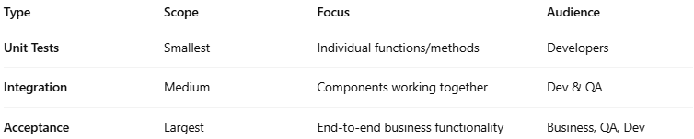
Type | Scope | Focus | Audience
Unit Tests | Smallest | Individual functions/methods | Developers
Integration | Medium | Components working together | Dev & QA
Acceptance | Largest | End-to-end business functionality | Business, QA, Dev

Explain
# Source: Chatgpt (GPT-5-Standard) at [8/13/2025]
You’ve got the essence of Acceptance Test-Driven Development (ATDD) right — let’s unpack it in more detail so it’s crystal clear.

What is ATDD?
# Source: Chatgpt (GPT-5-Standard) at [8/13/2025]
Acceptance Test-Driven Development is a collaborative software development practice where:
- Business stakeholders (product owners, customers)
- Developers (the people writing the code)
- Testers/QA (the people verifying correctness)
… work together to define acceptance tests before any development begins.
These acceptance tests are written in business-readable language (often Gherkin) so everyone understands exactly what needs to be built.

Key Idea
# Source: Chatgpt (GPT-5-Standard) at [8/13/2025]
- In TDD → Developers write unit tests before writing code.
- In ATDD → The whole team writes acceptance tests before writing code.
- The acceptance tests focus on what the system should do, not how it’s implemented.
- Passing these tests means the feature is done — it meets the Definition of Done.

How ATDD Works (Step-by-Step)

1️⃣ Collaborate on Requirements
# Source: Chatgpt (GPT-5-Standard) at [8/13/2025]
- All parties meet to discuss the feature.
- They identify acceptance criteria — clear, testable conditions for success.
- Criteria are turned into executable acceptance tests.
Example (Business-Level Language):
If a customer buys a product for $100 and the tax rate is 10%,
the total should be $110.

2️⃣ Write Acceptance Tests First
# Source: Chatgpt (GPT-5-Standard) at [8/13/2025]
- These tests are usually written in Gherkin or similar formats.
- They are executable through a tool like Cucumber, Behave, or SpecFlow.
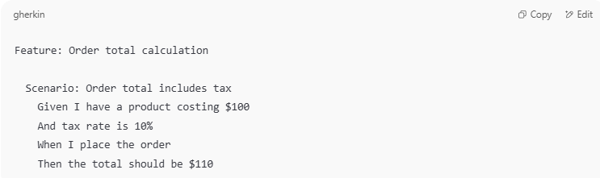
Feature: Order total calculation

Scenario: Order total includes tax
Given I have a product costing $100
And tax rate is 10%
When I place the order
Then the total should be $110

3️⃣ Implement the Feature
# Source: Chatgpt (GPT-5-Standard) at [8/13/2025]
- Developers write the code that makes the acceptance tests pass.
- They may still use TDD internally for unit-level details.
- But the driving goal is: "Make the acceptance tests pass."

4️⃣ Run Tests & Validate
# Source: Chatgpt (GPT-5-Standard) at [8/13/2025]
- Automated acceptance tests run against the system.
- If they pass → The feature is considered complete.
- If they fail → The code is not done yet.

Why ATDD is Powerful
# Source: Chatgpt (GPT-5-Standard) at [8/13/2025]
- Shared Understanding — Everyone agrees up front on what “done” means.
- Reduced Miscommunication — No surprises at the end of development.
- Higher Quality — Tests are based on real business needs.
- Traceability — Each feature’s success is measurable.

📌 In short:
ATDD turns acceptance criteria into living, automated tests that guide development from day one. Passing those tests is the proof the feature is complete — no subjective “I think it’s done” debates.

Core Idea
# Source: Chatgpt (GPT-5-Standard) at [8/13/2025]
- Focuses on what the system should do from the end-user’s perspective.
- Acceptance tests are written first and act as both requirements and verification.
- Involves all roles: Product Owner / Business Analyst, Developers, and Testers.

ATDD Process
# Source: Chatgpt (GPT-5-Standard) at [8/13/2025]
- Collaborate → Team discusses the feature and its acceptance criteria.
- Define Acceptance Tests → Written in clear, unambiguous language (often similar to BDD “Given–When–Then” format).
- Automate the Tests → Before writing feature code.
- Implement the Feature → Code is developed to pass the acceptance tests.
- Verify → Run the acceptance tests; feature is complete only if all pass.

Example (Gherkin style)
# Source: Chatgpt (GPT-5-Standard) at [8/13/2025]
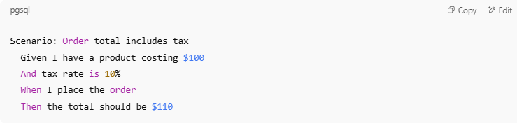
Feature: Order total calculation
Scenario: Order total includes tax
Given I have a product costing $100
And tax rate is 10%
When I place the order
Then the total should be $110

- This scenario becomes the definition of done for the feature.

ATDD (Acceptance Test–Driven Development) Recap
# Source: Chatgpt (GPT-5-Standard) at [8/13/2025]
- Goal: Collaboratively define the acceptance criteria for a feature before development starts.
- Participants: Customers/Product Owners + Developers + Testers.
- Output: Acceptance tests written in a clear, shared language (often Gherkin) that all parties agree on.
- Benefit: The acceptance test becomes the “definition of done” — development is complete only when the acceptance test passes.

Your Example in Context

Feature: Order total calculation
# Source: Chatgpt (GPT-5-Standard) at [8/13/2025]
- Description: The e-commerce system should correctly calculate the total price of an order, including tax.
- Business Goal: Avoid billing errors and ensure compliance with tax regulations.

Scenario: Order total includes tax

1. Given – Setup / Preconditions
# Source: Chatgpt (GPT-5-Standard) at [8/13/2025]
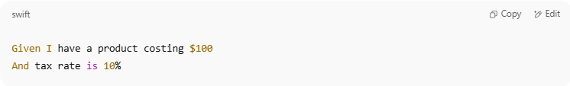
Given I have a product costing $100
And tax rate is 10%

- Meaning:
  - There’s a product in the system priced at $100.
  - The applicable tax rate is 10%.
  - The system’s tax rules are already configured.
- Business Perspective: This ensures the system has the right inputs before performing the calculation.

2. When – Action
# Source: Chatgpt (GPT-5-Standard) at [8/13/2025]
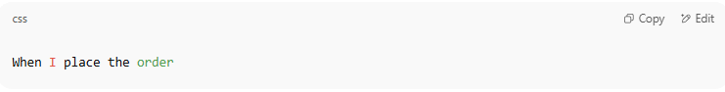
When I place the order

- Meaning:
  - The customer confirms and submits the order for checkout.
  - The system triggers its price calculation logic.
- Business Perspective: This is the moment where the system must apply tax rules correctly.

3. Then – Expected Outcome
# Source: Chatgpt (GPT-5-Standard) at [8/13/2025]
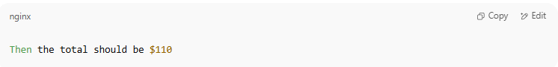
Then the total should be $110

- Meaning:
  - The system should add 10% of $100 ($10) to the base price, resulting in $110.
  - No rounding errors or miscalculations should occur.
- Business Perspective: If this passes, it shows the pricing and tax rules are applied correctly.

Why This Scenario Is the “Definition of Done”
# Source: Chatgpt (GPT-5-Standard) at [8/13/2025]
- In ATDD, this test is written first and agreed upon by all stakeholders.
- Development ends only when:
  - This automated acceptance test runs successfully.
  - The output matches the agreed business rule.
- It’s a living requirement — if business rules change (e.g., tax 15%), the acceptance test is updated before coding changes happen.

How It Might Look in a Cucumber Test
# Source: Chatgpt (GPT-5-Standard) at [8/13/2025]
Order_total.feature
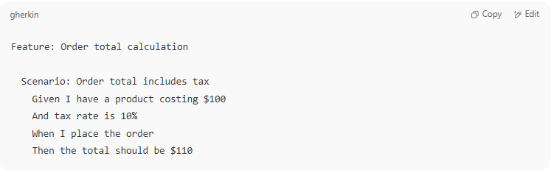
Feature: Order total calculation

Scenario: Order total includes tax
Given I have a product costing $100
And tax rate is 10%
When I place the order
Then the total should be $110

OrderSteps.java (Step Definitions in Java + Cucumber)
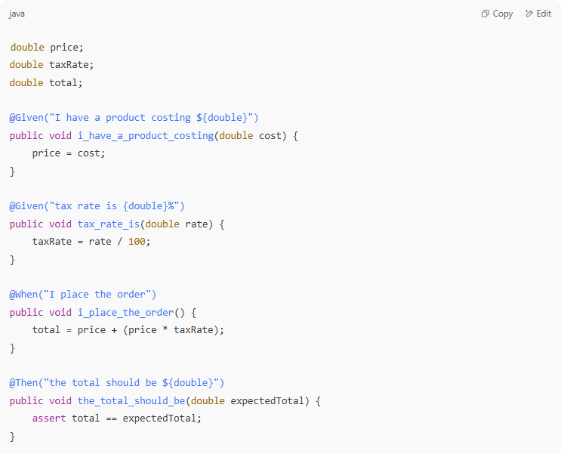
double price;
double taxRate;
double total;

@Given("I have a product costing ${double}")
public void i_have_a_product_costing(double cost) {
price = cost;
}

@Given("tax rate is {double}%")
public void tax_rate_is(double rate) {
taxRate = rate / 100;
}

@When("I place the order")
public void i_place_the_order() {
total = price + (price * taxRate);
}

@Then("the total should be ${double}")
public void the_total_should_be(double expectedTotal) {
assert total == expectedTotal;
}

When this runs and passes:
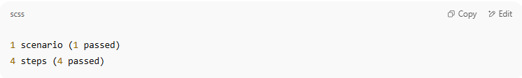
1 scenario (1 passed)
4 steps (4 passed)

✅ Feature complete — definition of done achieved.

Benefits
# Source: Chatgpt (GPT-5-Standard) at [8/13/2025]
- Clear definition of done agreed upon before coding.
- Reduced misunderstandings in requirements.
- Better collaboration between business and technical teams.
- Fewer defects since acceptance criteria are explicit and testable.
- Living documentation of expected system behavior.

ATDD vs. TDD vs. BDD
# Source: Chatgpt (GPT-5-Standard) at [8/13/2025]
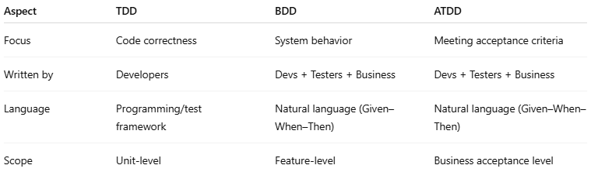
Aspect | TDD | BDD | ATDD
Focus | Code correctness | System behavior | Meeting acceptance criteria
Written by | Developers | Devs + Testers + Business | Devs + Testers + Business
Language | Programming/test framework | Natural language (Given–When–Then) | Natural language (Given–When–Then)
Scope | Unit-level | Feature-level | Business acceptance level

4-Continuous Testing in CI/CD

What is Continuous Testing in CI/CD
# Source: Chatgpt (GPT-5-Standard) at [8/13/2025]
Continuous Testing in CI/CD is the practice of running automated tests continuously throughout the software delivery pipeline — from code commit to deployment — so that quality issues are detected and fixed as early as possible.
It’s an essential part of Continuous Integration (CI) and Continuous Delivery/Deployment (CD) workflows.

Core Idea
# Source: Chatgpt (GPT-5-Standard) at [8/13/2025]
- Every time code changes (commit, merge, or build), a suite of automated tests runs.
- If any test fails, the pipeline stops, preventing bad code from progressing to production.
- Ensures fast feedback to developers.

How It Works in CI/CD

1-Code Commit (CI)
# Source: Chatgpt (GPT-5-Standard) at [8/13/2025]
  - Developer pushes changes to the shared repository.
  - Build server (e.g., Jenkins, GitLab CI, GitHub Actions) triggers the pipeline.
Developer Pushes Changes
- A developer writes new code or updates existing code.
- Changes are pushed to a shared repository (e.g., GitHub, GitLab, Bitbucket) via Git.
- This triggers the CI server (e.g., Jenkins, GitLab CI, GitHub Actions) to start the pipeline automatically.
Why it matters:
- Ensures all changes are integrated frequently into a common codebase.
- Prevents “integration hell” where merging becomes messy after long delays.

2-Automated Testing Stage
# Source: Chatgpt (GPT-5-Standard) at [8/13/2025]
  - Unit tests: Verify individual functions/classes.
  - Integration tests: Check that modules work together.
  - API tests: Validate backend services.
  - UI tests: Simulate user interactions.
  - Performance/security tests (in some pipelines).

This is the heart of CI — every commit is tested to detect problems immediately.
a) Unit Tests
- Purpose: Verify small pieces of code in isolation — a single function, method, or class.
- Speed: Very fast, often run in milliseconds.
Example:
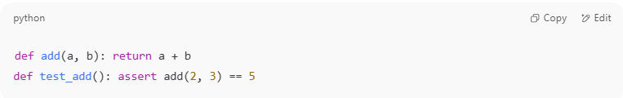
python
def add(a, b): return a + b
def test_add(): assert add(2, 3) == 5

- Benefit: Catches low-level logic errors early.

b) Integration Tests
- Purpose: Ensure multiple components/modules work correctly together.
- Example: Verifying that the payment service correctly interacts with the order database.
- Scope: Broader than unit tests; may involve multiple classes, APIs, or databases.
- Benefit: Detects issues in how parts of the system interact.
c) API Tests
- Purpose: Test backend endpoints for correct responses, data structure, and error handling.
- Example: Sending a POST request to /orders and verifying HTTP 201 and correct JSON.
- Tools: Postman, REST Assured, pytest, Karate.
- Benefit: Ensures backend services behave as expected for clients.

d) UI Tests
- Purpose: Simulate user actions on the application interface.
- Example: Using Selenium to log in and check if the dashboard loads.
- Scope: End-to-end (E2E) testing from user perspective.
- Benefit: Verifies the complete user journey.

e) Performance & Security Tests (optional in CI, common in CD or nightly runs)
- Performance Testing: Check speed, scalability, and load handling.
- Security Testing: Detect vulnerabilities (SQL injection, XSS, dependency scanning).
- Benefit: Proactive quality and security assurance.

3-Feedback Loop
# Source: Chatgpt (GPT-5-Standard) at [8/13/2025]
  - If all tests pass → Code moves to next stage (staging/deployment).
  - If tests fail → Developer is alerted immediately to fix the issue.
Pass Case
- If all tests pass, code moves automatically to the next stage:
  - Staging environment for further checks
  - Direct deployment if using full Continuous Deployment
Fail Case
- If any test fails, the pipeline stops.
- Developer receives instant feedback (via email, Slack, or dashboard).
- They fix the issue before merging more code, keeping the main branch stable.
💡 Fast feedback is key in DevOps — the earlier a bug is found, the cheaper it is to fix.

4-Deployment (CD)
# Source: Chatgpt (GPT-5-Standard) at [8/13/2025]
  - Additional smoke tests and regression tests may run in staging or production environments.
Once code passes the automated testing stage:
Staging Deployment
- Code is deployed to a staging environment that mirrors production.
- Additional tests run:
  - Smoke Tests: Quick checks that the application is up and basic functions work.
  - Regression Tests: Ensure old features still work after the new change.
Production Deployment
- With Continuous Deployment: Pushes happen automatically if staging passes.
- With Continuous Delivery: A human approves before production release.

5-Post-Deployment Checks
# Source: Chatgpt (GPT-5-Standard) at [8/13/2025]
- Monitoring: Observes performance, error rates, and logs.
- Synthetic Testing: Simulated user actions running periodically to ensure uptime.
- Rollback Mechanisms: If a serious bug appears, system can revert to the last stable release.

Pipeline Flow Overview
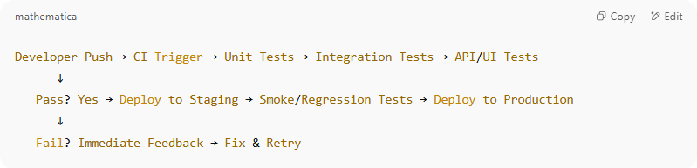
Developer Push → CI Trigger → Unit Tests → Integration Tests → API/UI Tests
↓
Pass? Yes → Deploy to Staging → Smoke/Regression Tests → Deploy to Production
↓
Fail? Immediate Feedback → Fix & Retry

Benefits
# Source: Chatgpt (GPT-5-Standard) at [8/13/2025]
- Faster feedback → Developers know within minutes if something is broken.
- Higher quality releases → Bugs are caught before production.
- Reduced cost of fixing defects → Issues found earlier are cheaper to fix.
- Confidence in automation → Enables safe, frequent deployments.

Example
# Source: Chatgpt (GPT-5-Standard) at [8/13/2025]
Imagine a CI/CD pipeline for a web application:
- Developer pushes a commit to main.
- Jenkins runs:
  - Unit tests (JUnit)
  - API tests (Postman/Newman)
  - UI tests (Selenium/Cypress)
- Pipeline fails if any test fails → Code never reaches production until fixed.

